- Sonden-Durchmesser
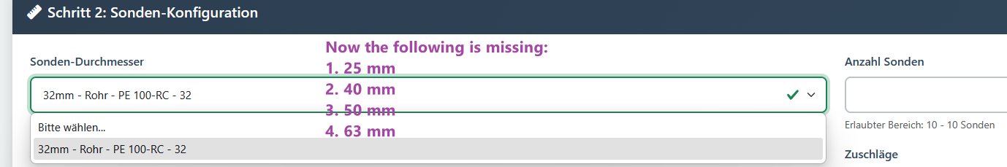

- Sondenabstand
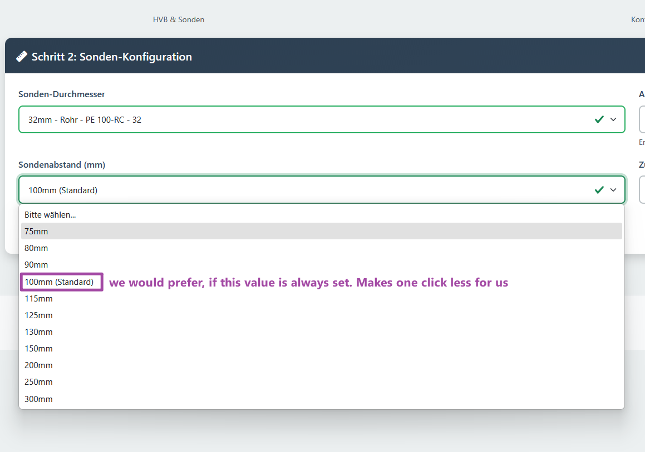
- Durchflussmesser
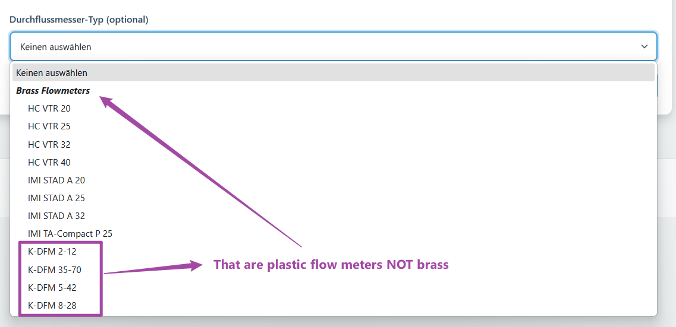

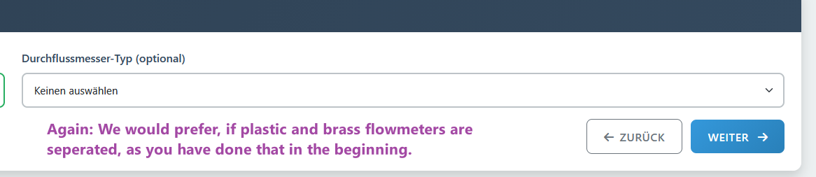

- Artikelnummern
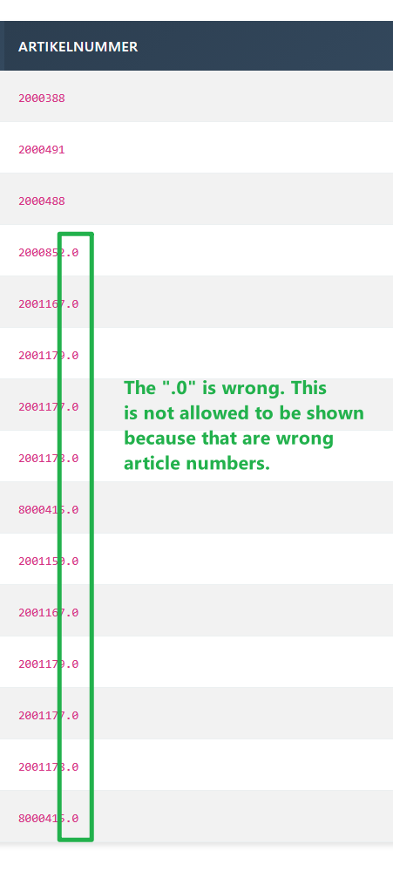
- BOM – Quantities wrong & articles missing
I tested a existing configuration:
In the first picture the more or lest correct configuration and in the second screenshot what the BOM configurator gave as an output. Here are the quantities still completely wrong and there are several articles missing. And in my green comment in the second screenshot, there are articles, which should not be in there.
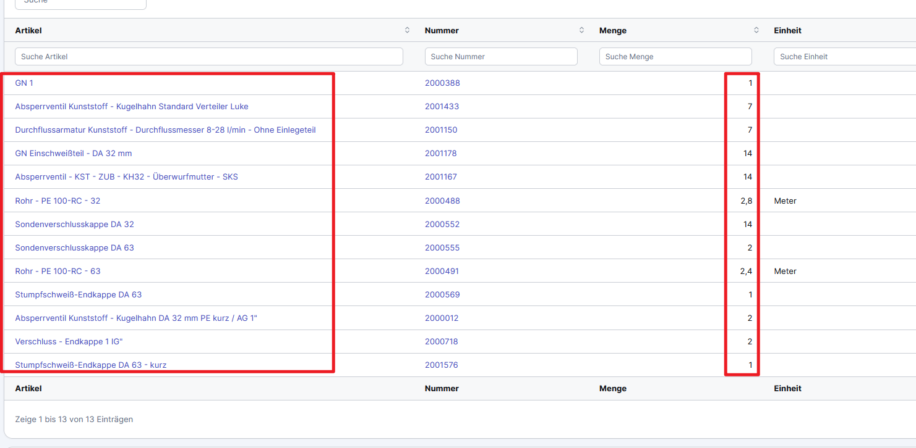
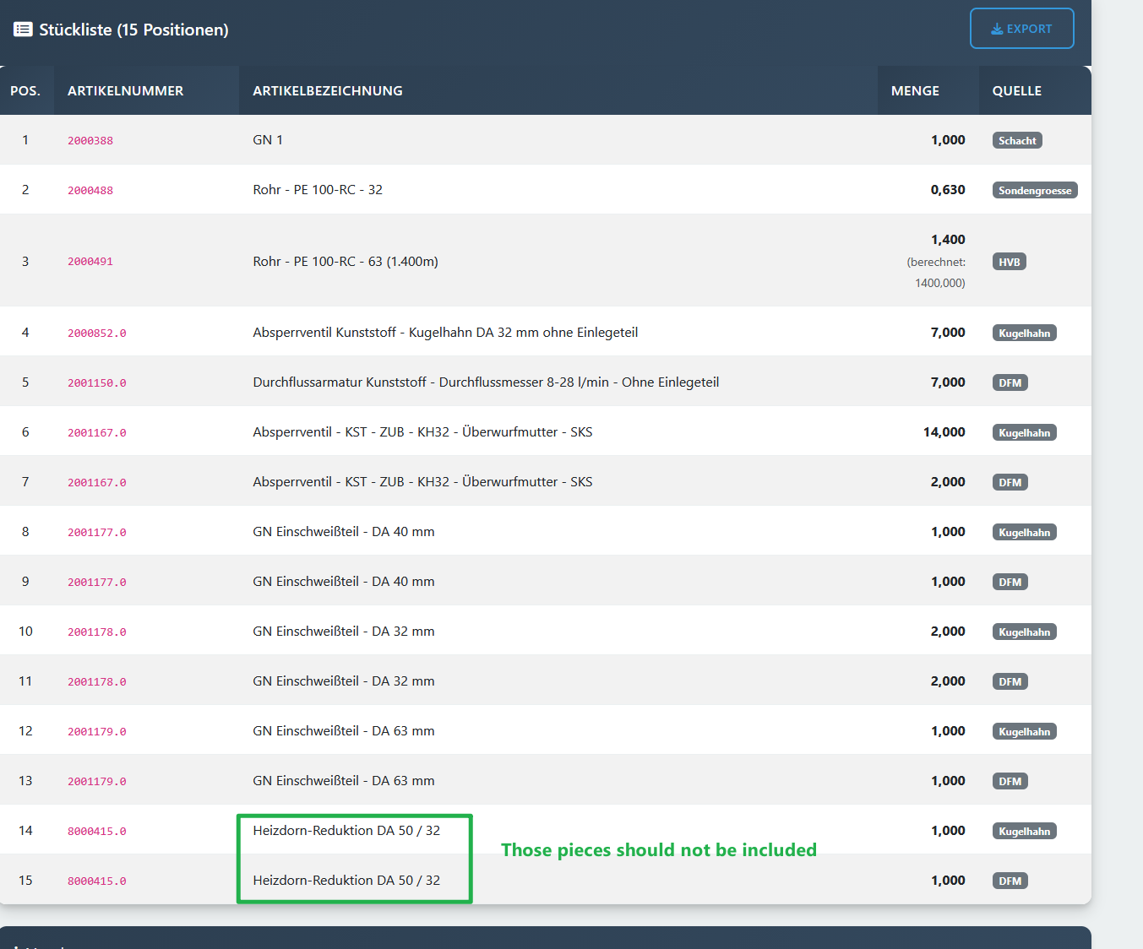
- Old BOM Configurator
I liked actually that the length was calculated. Could this be please put in again?
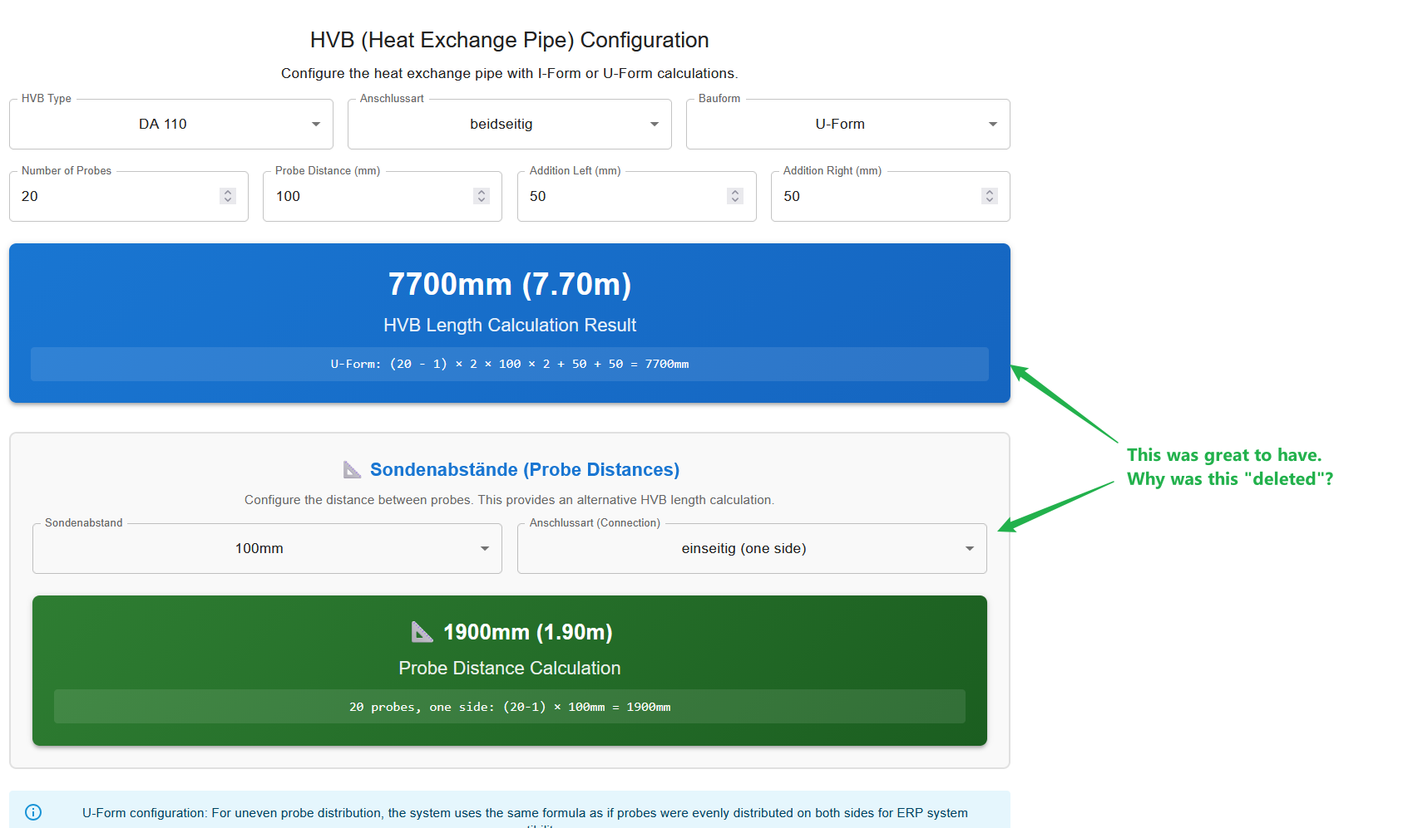

- Article check (existing configurations)
